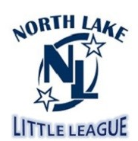
2022 Season
North Lake Little League
PO BOX 82893
Kenmore WA, 98028
Tax ID # 91-0989121

Thank you for your donation in the amount of $___________ to North Lake Little League. North Lake Little League is a non-profit 501(c)(3), all volunteer organization dedicated to the enjoyment and development of children through their participation in T-ball, softball and baseball programs. Our league offers programs each Spring to children between the ages of 5 and 14 in the Bothell, Kenmore and Brier area. We currently have more than 400 children enrolled in the league and playing ball!

North Lake Little League is funded by player registrations, team sponsors and donations. We could not operate the league without this support.

The North Lake Little League thanks you for your donation to keep our kids playing ball!

Sincerely,

Treasurer
North Lake Little League

